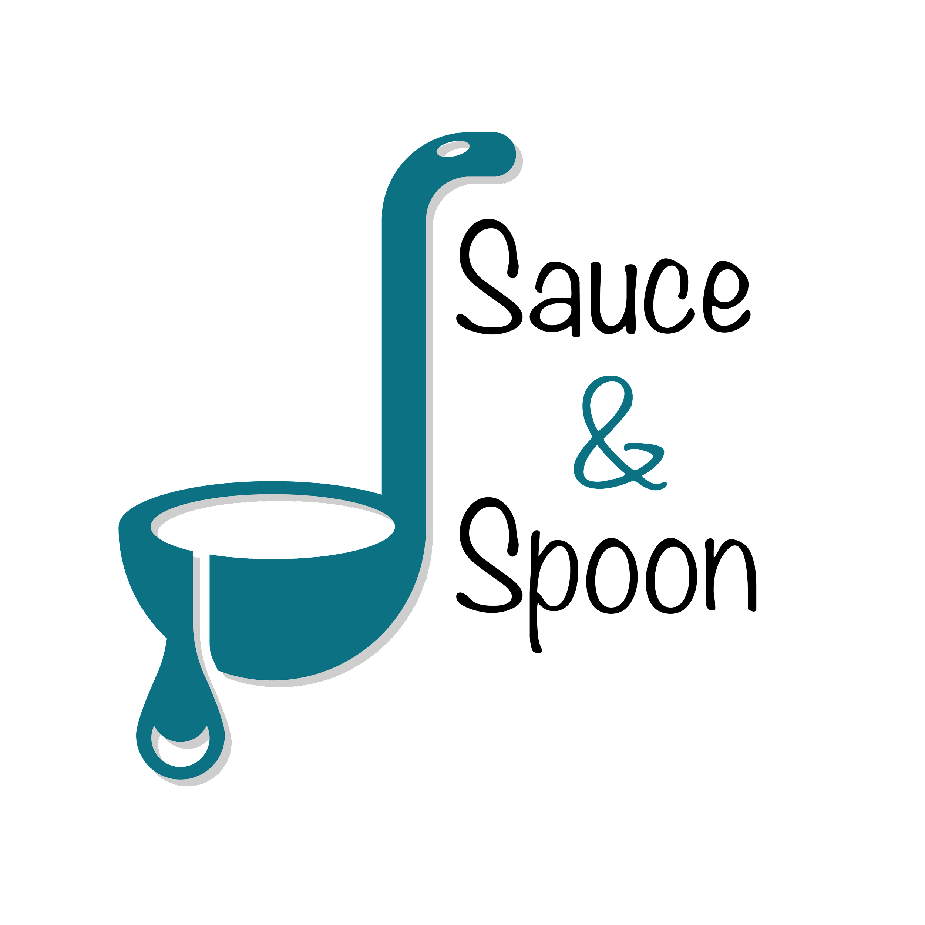

Project Charter: [Menu Tablets]

DATE: [29/07/21]

| **Project Summary** |
| --- |
| Sauce & Spoon would like to launch a pilot rollout of tabletop menu tablets at two of our restaurant locations, Sauce & Spoon North and Sauce & Spoon Downtown. That way, guests can place their orders on the tablets as soon as they arrive at the restaurant, rather than waiting for a server to attend to them. |

| **Project Goals** |
| --- |
| * Increase product mix * Increase daily guest counts by 10% * Reduce table turn time by 30 minutes by the end of Q2, resulting in decreased customer wait time. * Implement menu tablets by the start of Q2 * Cut food waste by 25% by the end of Q2 * Reduce operation costs * Improve quality and customer satisfaction * Increase the average check total to at least 75$ by selling more appetizers and specialty drinks by the end of Q2, resulting in increased profits. * Increase appetizer sales by 15% on average, with the North location targeted for 10% increase and the Downtown location targeted for 20%. |

| **Deliverables** |
| --- |
| * Pilot the tablets in April. * Allow the tablets to communicate specific guest requests to the kitchen. * Have a feature to promote specific items. * Have a training plan for employees. * Integrate the existing POS system and host software with the tablets. |

| **Scope and Exclusion** |
| --- |
| **In-Scope:**   * Pilot the tablets in April * Allow the tablets to communicate guest requests to the kitchen * Have a feature to promote specific items   **Out-of-Scope:**   * Policy change on order returns. * Payroll allocations. |

| **Benefits & Costs** |
| --- |
| **Benefits:**   * The tablets will provide the restaurant with clear data points on customer ordering and an integrated point-of-sale system to help guide decision-making in the future. * Speed up service. * Increase in sales & revenue.   **Costs:**   * Training materials and fees: $10,000 * Hardware and Software Implementation across locations: $30,000 * Maintenance (IT fees through EOY): $5,000 * Updated website and menu design fee: $5,000 * Other customization fees: $550 |

| **Appendix:** |
| --- |
| * Making payroll allocations to staff. Agreeing to measure the tablet's impact by the end of June before discussing the payroll allocations. * Goal setting and measurement. Agreeing to keep the goal of reducing table turn time instead of measuring a reduction in guest wait time. * Making policy changes on order returns. Agreeing on making policy adjustments not part of the project’s scope. * Increasing Employee satisfaction. Agreeing on providing specific metrics for improving kitchen staff satisfaction before adding it to the project’s scope. |